CURRICULUM OF ENGLISH
CLASS XII
2021-2022

General Objective: To lead the learners to substantiate an understanding of the connection between writing and thinking and
demonstrate effectiveness in using verbal and non verbal language appropriate to the goal.
- Improve communication between student – student and teacher-student.
- To develop academic skills.
- To enhance the students’ knowledge of subject content.
- To read literature with an appreciation for inter-relatedness of plot, character, theme and style.
- Form an appreciation for all genres of literature.
- To encourage goal- oriented teamwork.

PROJECTED  CONTENT | METHODOLOGY | LEARNING OUTCOMES
APRIL
(21 days)
The Last  Lesson (Flamingo) | The session would begin with an interaction on homework – and the way you treat it. (Student-Teacher Interaction) The learners would interpret the title of the lesson. The background knowledge of the author and his works would be given. The facilitator would develop the chain of events, with TEXT sequence or discourse/spoken with reference to the educational and personal domains. Difficult words and terms would be discussed. The prose will be explained. All possible questions and answers would be discussed and assigned. | They would develop their  optimistic attitude towards  life amidst many struggles.  They would be able to  familiarize themselves with  specific background  information of Alphonse  Daudet/ history of France.  They would be able to make  connections between similar  situations in different  storylines/life experiences  like Indians under British  imperialism.
TIGER KING  (Vistas) | The session would start with a  short video on save tiger. The  learners would interpret the  title of the story and relate it  to the video shown.  The background of the author  would be given. The story  would be read aloud. The  theme and underlying  meaning would be discussed.  A comparative study between  Mrs Packletide’s Tiger and the  lesson.  Difficult words would be listed  and explained. The moral of  the story would be discussed. | The Learners will be able to  uncover motives, absorb  didactics.  They would be able to  familiarize with specific  Royal Indian background  information of the  author/history of cruel  insensitive kings who found  pleasure in hunting and  killing innocent animals.  They would understand the  importance of becoming  sincere and trustworthy in  thought and action.  They would be  understanding, responsible,  tolerant and have respect for  class identities – democratic  citizenship.
My Mother at  sixty-six  (Flamingo) | Pre-reading activity would be  the first step wherein the  students would delve deep  into the title of the poem and  make an interpretation of the  title as it indicates the subject  and theme.  (student- teacher interaction)  They would compare the  poem with the poem A  Photograph.  The background of the poet  would be discussed.  The poem would be read  aloud with proper intonation  rhyme and rhythm.  Difficult terms and words  would be explained so that  the students can predict the  atmosphere of the world  inside the poem.  The poem would be explained  covering the phrases,  sentences and discourse as  well as their structuring.  Silent reading of the poem by  the students within five  minutes and listing the  difficult terms.  The figures of speech and  rhyme scheme would be  discussed. | The students would be able  to grasp the theme and  meaning of the poem.  They would be able to read  the poem with proper tone  and rhyme and develop an  interest in poetry.  Their vocabulary would be  strengthened.  Their analysing skills would  be enhanced.
WRITING  SKILLS  Notice Writing | Warm up session:  Learners would share their  knowledge on the importance  of a notice(Student- Teacher  interaction)  The Learners would be asked to speak about a notice they  received and they remember  still.  The teacher would explain  what a notice is and its  purpose. The standard format  of notice writing would be  shown in the class. The  teacher would discuss in detail  what a notice should contain.  The wide range of themes and  objectives covered by notice  would be discussed with  examples  Special note on-  5 Ws  What  Where  When  Who  Whom | Students will be able to  analyse any NOTICE shown  to them on the basis of the  knowledge imparted.  They will be able to frame  notice about any event.  They will be able to identify  important information in any  given notice.  Students will be able to use  appropriate style and format  to write a NOTICE  effectively.
INVITATION  WRITING/  REPLIES | Developing the format in  sequence or discourse/spoken  with reference to the educational, personal  domains.  The teacher would discuss  with examples all kinds of  invitations and the method of  framing replies. | The learners would be able  to express their ideas  cohesively, completely, fluently and spontaneously  with expressions, grammar  usage and relevant  vocabulary for a hospitable  announcement of an event.
NOTE MAKING | In the beginning of the  session, a text would be  provided to the students to  read and involve in note  making to test previous  knowledge.  The facilitator would train the  students to read a text  minutely, or listen carefully to select, analyse and summarize  the main points.  Ways of making notes would  be discussed:  Annotation, outline notes,  column notes, mind maps and  summary notes. | The learners would be able  to differentiate between  annotation, outline notes,  column notes, mind maps  and summary notes from a  text.  They would be able to use  the note taking suggestions  to develop good notes based on classroom discussions.
MAY
(21 days)
DEEP WATER | The session would begin with  an interactive session wherein  the teacher would ask the  students to discuss about their  phobias as related to the  theme of the lesson.  The prose would be read  aloud. Difficult words would  be discussed.  The story outline, theme and  values would be discussed by  the teacher through a Power  Pont Presentation The students would be  grouped into six for the varied  activities, discussions and  presentations.  The students would be  grouped into six for the varied  activities, discussions and  presentations. | The learners would unfold  their logical thinking skills.  Their vocabulary will be  enriched.  They would be able to  organize their thoughts,  research work, compile and  present in an economic  writing style.  The creative writing skills  would be enhanced. They  would develop their listening,  speaking, questioning and  presentation skills.  They would strengthen their  decision making skills.
LOST  SPRING  (Flamingo) | The session would begin with  an audio –video presentation  on the plight of poor children.  The learners would be asked  to interpret the title of the  lesson relating it to the  presentation.  The background of the author  would be given. The theme  and story line would be  explained.  The teacher would develop  the format in sequence or  discourse spoken with reference to the ethical/global  and personal domains. | Learners will be able to  sensitize the learners to the  problem of child labour.  They would be able to identify  the problem, consider the  options, weigh the pros and  cons of each option, and reach  a decision/opinion/solution.  They would enhance their  analytical skills.  They would be able to uncover  the motives of the poor parents/policemen/  Industrialists/middlemen.  They would be able to absorb  didactics and inspiration.  They would strengthen their  integrated skills.
KEEPING  QUIET  (Flamingo) | The session would begin with  the study of silence. The  teacher would ask the learners  to maintain silence and the  study the sounds of silence for  one minute.  The learners would discuss on  the sounds and thoughts of  silence and relate to the title  of the poem.  The background of the author  would be given.  The poem would be read  aloud and discussed. Difficult  words would be listed out and discussed.  The synopsis would be shown  with the help of a PPT. | The learners would be able to  understand the need of the  hour to maintain peace and  cut out the clamour and  bloodshed, correlating it with  contemporary background  and personal experiences.  They would be able to up  threat and gentle heeding  with the predictable loss of  the world. (global domain)
WRITING  SKILLS  Article Writing | The session would start with a  pre-writing activity to create  an interest towards writing.  The teacher would define  what an article is and discuss  the purpose of article writing.  The different styles, subjects,  purpose of article writing  would be discussed. The  teacher would explain the  technique of accumulating  ideas, focussing on ideas and  facts, planning, organizing,  evaluating, structuring and  editing. They would be taught  the importance and way of  producing a finished piece of  work with examples. The  requirements of the content,  beginning, body and end  would be focussed. | The students would develop  an interest towards writing.  Their planning and organizing  techniques would be  enhanced. They would be able  to research on any subject and  derive information from facts  and present him in the form of  a written piece. Their creative  writing would be analysed.  The interpreting and  evaluative skills would be  strengthened.
REPORT  WRITING | The teacher in the beginning  of the session would give  students the opportunity to  collect information on a  declared issue before writing  the report.  During the session students  will go through the process of  developing ideas and  collecting and organising  information. They will then  use the information to create  the first draft of an imaginary  report. They will then focus on  some key areas of good  writing and try to redraft their  reports with these in  mind.(Inductive Learning) | The learners will be able to  discuss the purpose of various  reports.  They will be able to describe  the kinds of information to  include in specific reports and  identify tips for writing a clear,  concise, and useful report.  They will recognize and  address patterns and trends  and be able to explain how the  tone of a report can affect  worker morale and  motivation.
JULY
(25 days)
ELEMENTARY  SCHOOL  CLASSROOM IN  A SLUM  (Flamingo) | Pre- reading Activity:  The session would start with  an interaction on  Government’s eye on the  schools of the slum areas.  The title of the prose would be  open for class interpretation.  The facilitator would develop  the format of text in sequence or discourse (spoken with  reference to the  ethical/global, public and  personal domains of social  and personal life. | The learners would familiarize  themselves with specific  background information of  social inequalities.  They would recognize the  purpose of theme and the  hidden pathos and nuances of  the lines, correlating them with indigenous/ personal  experiences.  They would be able to build up  empathy and sympathy with  the prevalent inequalities of  the society which rest on  financial status and lost  opportunities for children.
THE RATTRAP  (Flamingo) | The session would begin with  an interactive stage wherein  the students would discuss on  the temptations in life on  basis of the theme of the  story.  The title of the lesson would  be opened to the class for  interpretation.  The background knowledge of  the author would be given.  The prose would be explained.  Difficult words would be listed  and explained. The moral of  the story would be discussed. | The students would be able to  effectively provide a synopsis  of the story.  They will be able to analyze  the values and thought  process of the story.  They would be able to identify  the insecurity while tackling  personal fears and horrors  that lurk in the recesses of our  mind.  They would be able to  appreciate the significance of  developing personal fears yet  rising above them to savour  real liberty.  Their vocabulary would be  enriched.
WRITING  SKILLS | The format, rules, technique  would be discussed with  examples. | The learners would be able to  organise their thoughts and  express freely.
Letter to the  Editor | The usage of language would  be taught and students would  be assigned written tasks. | They would develop an  interest towards writing thus  enhancing their writing skills.  Their thinking skills would be  enhanced.
POSTER  MAKING | The teacher will acquire and  display several different  posters from various sources.  Some examples may include:  Movie posters, Community  events, Advertisements  Campaign signs, Billboard  pictures  Full-page newspaper ads  Learners will brainstorm the  purpose of posters.  (Student- Teacher Interaction)  Some responses may include:  To get people’s attention  To get people to do something  To give people information.  The teacher would discuss and  demonstrate the presentation  stage, consolidation stage and  the closing stage. | Comprehend an effective  Poster making as a tool of  Visual Communication.  Focus on the message to be  delivered.  Keep the sequence well  ordered.  Use graphs and images  effectively.  Plan and organize a poster  presentation.  Use spacing, margins, colours,  and layout to maximize  effectiveness and list  information about their  invention.
AUGUST
(22 days)
SHOULD WIZARD  HIT MOMMY  (Vistas) | The session would start with  an interaction on Are  nursery rhymes and fairy  tales a reflection of reality?  The title of the lesson would  be open for interpretation.  The background of the  author would be given. The  lesson would be read aloud  and discussed. Difficult  words would be listed out  and discussed. | The learners would be able to  familiarize with specific  background while tackling  personal choices on security,  familiarity and happiness.  They would be able to make  connections between similar  situations in personal  experiences.  They will be able to appreciate  the timeless significance of  universal fears of loss and  gain, of happy ending and  parenting issues
ON THE FACE OF  IT  (Vistas) | The session would start with  an interaction on  appearances are deceptive.  The title of the story would  be open for interpretation.  The background of the  author would be given. The  prose would be read aloud  and discussed.  It would follow by  Developing the format of  text in sequence or  discourse /spoken with  reference to the global,  cultural, public domains of  social life. | The learners would be able to  fight out their loneliness,  depression and  disappointment.  They would accept the  physically challenged people  positively in their life and  expand their social  interaction.  They would be able to build up  optimism and self confidence.
WRITING SKILLS  Advertisement  (commercial/  classified) | A visual clipping of  advertisements would be  shown to the learners and  they would interpret it  through interaction.  (student-student  interaction)  The concept, format, style  and purpose would be  explained with examples. | Students will learn persuasive  techniques used in  advertising, specifically,  pathos or emotion, logos or  logic, and ethos or  credibility/character. They will  use this knowledge to analyse  advertising in a variety of  sources: print, television, and  Web-based advertising.  Students will also explore the  concepts of demographics and  marketing for a specific  audience.
LETTER  WRITING:  Enquiry/Reply  Order/Complaint  /Reminder/Canc-  ellation.  Replies to the  Letters. | The lesson consists of three  stages that are outlined  below:  1) An ordering activity for  group work with cards: Each  group will be given a set of  cards to order and the  teacher will constantly  observe and move during  the activity to provide any  assistance required. The correct version will then be  displayed on the Green  Board.  2) Find the deliberate  mistakes for pair work: To  vary the forms of interaction,  this time the learners will be  asked to work on the activity  in pairs and photocopies will  be provided. The correct  answers will then be elicited.  3) A Questionnaire through  which the learner can find  out how much they know  about letter writing: The  students can work on this  individually and photocopies  will be provided for this  purpose. (Inductive  Learning)  The format, usage, purpose  and style would be  demonstrated with  examples. | The learners will be able to  express ideas fluently and  chronologically, concisely  without difficulty in purpose,  expressions, grammar usage,  format usage and relevant  vocabulary.  They will be able to express  request/complaint/reminder/  cancellation fluently and  orderly without difficulty in suitable tone and expressions  and relevant vocabulary.
SEPTEMBER
(14 days)
Recapitulation of Writing Skills and literature
HALF YEARLY EXAMINATION
OCTOBER
(21 days)
GOING PLACES  (Flamingo)  THE ENEMY  (Vistas) | The session would begin with  an interaction on Fantasy and  Reality.  The title of the lesson would  be open for class  interpretation.  The background of the author  would be given. The lesson  would be read aloud and  discussed. Difficult words  would be listed out and discussed.  The session would start with  an interactive session on the  services of a doctor.  The title of the lesson would  be open for class  interpretation.  The background of the author  would be given.  The lesson would be read  aloud and explained. The  historical background of the  story and war related issues  would be discussed.  Difficult words would be listed  out and discussed. | The learners will be able to  familiarize themselves with  specific background  information of adolescents  and adolescent fantasizing.  They would identify and make  connections between similar  situations in own life  experiences where each of us  suffers dreams are not rooted  to the ground of common  sense and tend to be exotic,  glamorous and sophisticated  The learners will be able to  familiarize themselves with  specific background of political  enmity.  They will be able to identify  and make connections  between similar situations in  own life experiences where  our prejudices often hinder  our human compassion and  empathy for a political enemy.  They will be able to  understand the significance of  professional ethics and social  obligation in sensitive times.
NOVEMBER
(20 days)
EVAN TRIES AN  O’ LEVEL  (Vistas) | The session would start with  an interaction on Would  Education in the jails help in  refining prisoners.  The title of the lesson would  be open for class  interpretation.  The background of the author  would be given. The lesson  would be read aloud and  discussed. Difficult words  would be listed out and discussed | The learners will be able to  familiarize themselves with  specific background of the cat  and mouse role of the police  and the criminal.  They will be able to identify  and make connections  between similar situations in  their own country where each  of us witness the dereliction of  duty of the law keepers and  their complacent laxity.
WRITING  SKILLS  Letter of Job  Application | The teacher would stress the  students on the importance of  application – they may lead to  an interview and discuss the  content of a letter of  application and note the  responses on the  blackboard/or discuss through  a PPT. | The learners will be able to  understand the nature and  purpose of a letter of  application.  They will be able to examine a  variety of letters to determine  best layout, content and style.  They will be able to develop  and produce their own letter  of application and prepare  cover letter and attached bio  data.
DECEMBER
(25 days)
MEMORIES OF  CHILDHOOD  (Flamingo) | The session would begin with  a presentation on the great  personalities who fought  against social injustice.  The title of the lesson would  be open for class  interpretation.  The background of the author  would be given. The lesson  would be read aloud and  discussed. Difficult words  would be listed out and  discussed. | The learners would be able to  sensitize themselves to the  issues of estranged cultural  ties.  They will be able to make  connections between similar  situations in different  storylines/life experiences.  They will be able to initiate  the role of an ambassador in  the world ridden with racial  and class differences.  They would be able to  recognize the universal/global  theme of inequality.
AUNT  JENNIFER’S  TIGERS  (Flamingo) | Pre-reading activity would be  the first step wherein the  students would delve deep  into the title of the poem.  The learners would make an  interpretation of the title as it  indicates the subject and  theme.  The background of the poet.  would be discussed. The poem  would be read aloud with  proper intonation rhyme and  rhythm.  Difficult terms and words  would be explained so that  the students can predict the  atmosphere of the world  inside the poem.  The poem would be explained  covering the phrases,  sentences and discourse as  well as their structuring. Silent  reading of the poem by the  students within five minutes  and listing the difficult terms.  The figure of speech and  rhyme scheme would be  discussed. | The learners will be able to  facilitate making connections  between similar situations in  different storylines/life  experiences.  They will be able to  empathize with Aunt  Jennifer’s problems and seek  resolution.  They will be able to think and  produce spontaneous, fluid  and expression in poetic texts  to convey a social change.  They would discern prevailing  inequalities in various guises.
JANUARY
(16 days)
REVISION AND PREPARATION for PRE BOARD
 | FEBRUARY
RECAPITULATION and PREPARATION FOR FINAL ASSESSMENT

CURRICULUM (041) : 2021-22

SUBJECT : MATHEMATICS
CLASS : XII
Objectives :
The aims of teaching and learning mathematics are to encourage and enable students to:
- To acquire knowledge and critical understanding, particularly by way of a motivation and visualization, of basic concepts, terms, principles, symbolsand mastery of underlying processes and skills.
- To feel the flow of reasons while proving a result and solving a problem.
- To apply the knowledge and skills acquired to solve problems and whereber possible, by more than one method.
- To develop positive attitude to think, analyze and articulate logically.
- To develop interest in the subject by participating in related competetions.
- To acquaint students with different aspects of Mathematics in daily life.
- To develop an interest in students to study Mathematics as a discipline.
- To develop reverence and respect towards great Mathematicians for their contributions to the field of Mathematics.
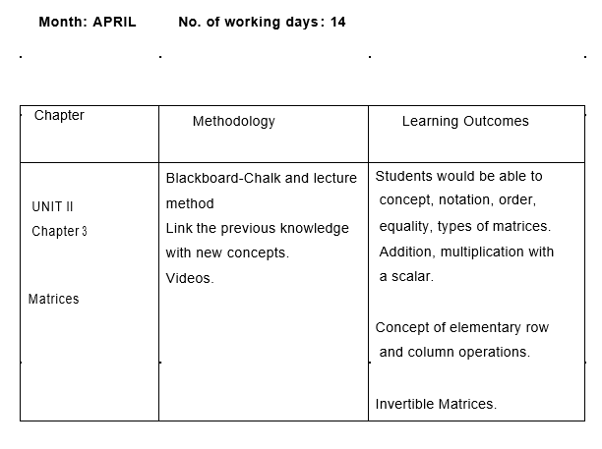

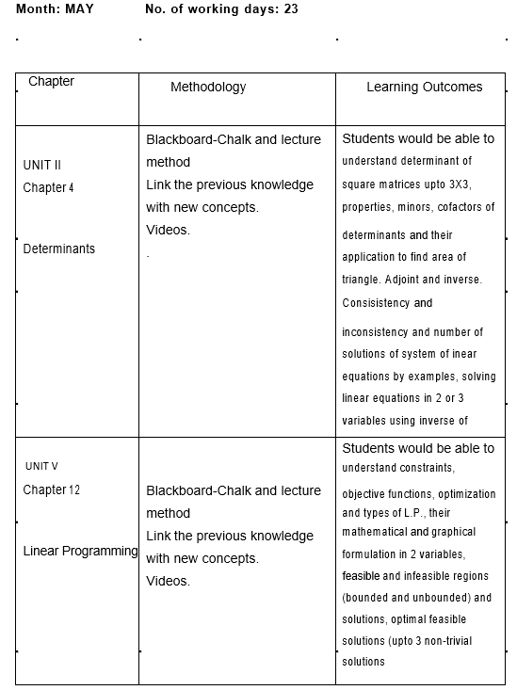

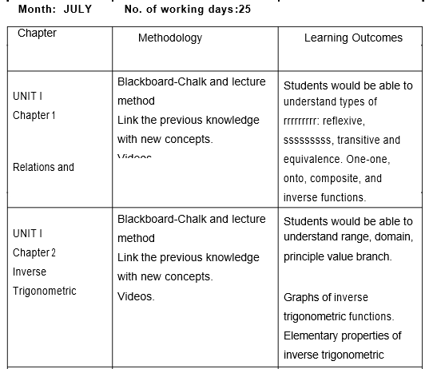
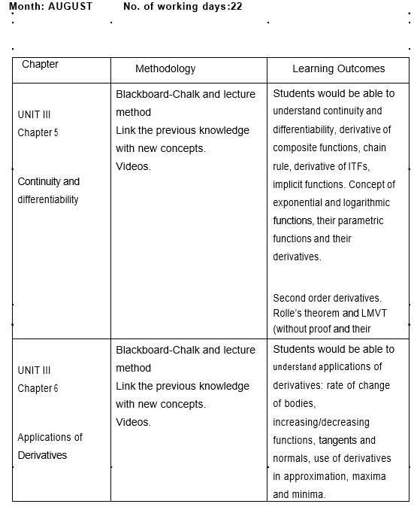

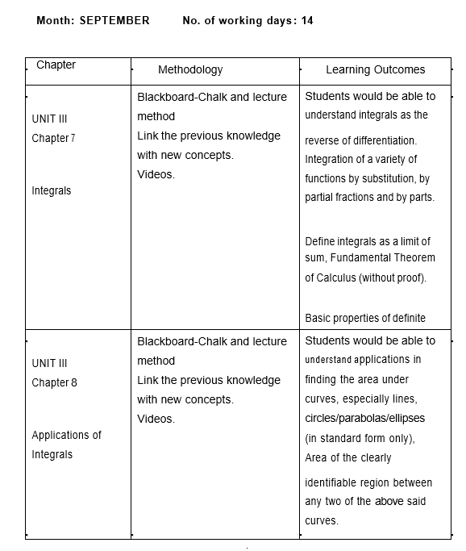

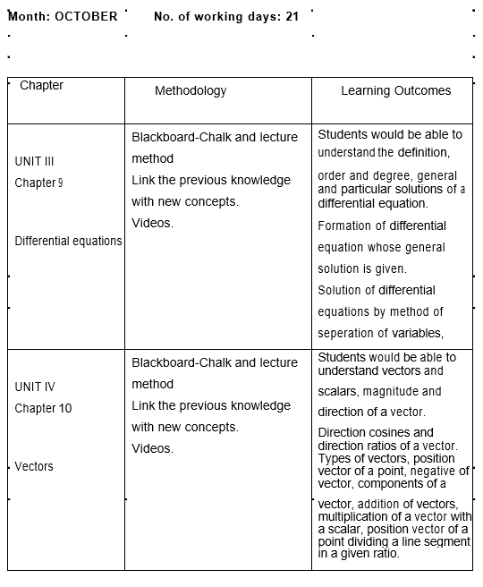

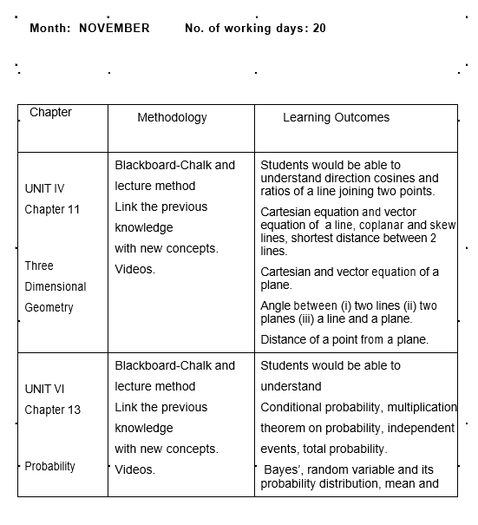

CURRICULUM (241) : 2021-22
SUBJECT : MATHEMATICS
CLASS : XII

Objectives :
The aims of teaching and learning mathematics are to encourage and enable students to:
- To acquire knowledge and critical understanding, particularly by way of a motivation and visualization, of basic concepts, terms, principles, symbolsand mastery of underlying processes and skills.
- To feel the flow of reasons while proving a result and solving a problem.
- To apply the knowledge and skills acquired to solve problems and whereber possible, by more than one method.
- To develop positive attitude to think, analyze and articulate logically.
- To develop interest in the subject by participating in related competetions.
- To acquaint students with different aspects of Mathematics in daily life.
- To develop an interest in students to study Mathematics as a discipline.
- To develop reverence and respect towards great Mathematicians for their contributions to the field of Mathematics.

Month: APRIL No. of working days : 14

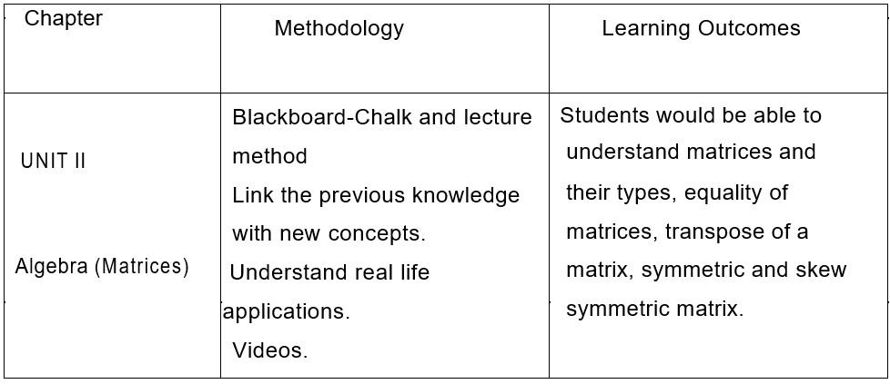

Month: MAY No. of working days: 23

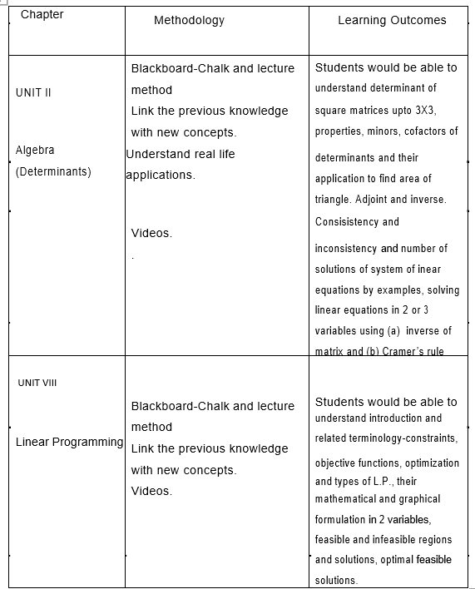

Month: JULY No. of working days :25
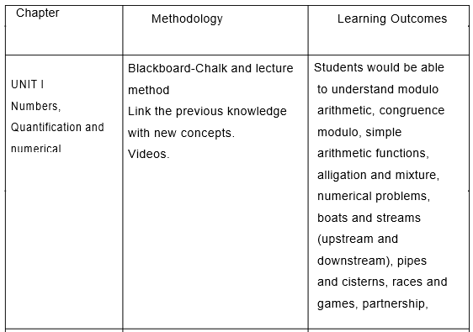

Month: AUGUST No. of working days :22

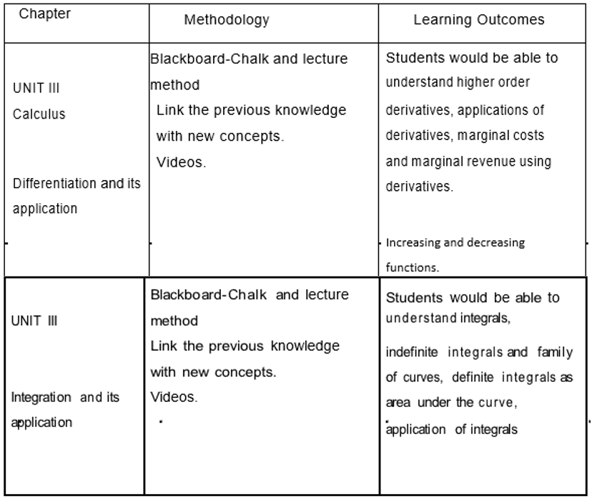

Month: SEPTEMBER No. of working days : 14
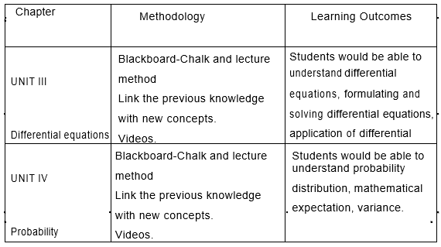

Month: OCTOBER No. of working days: 21

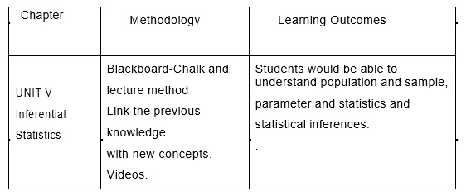

Month: NOVEMBER No. of working days : 20

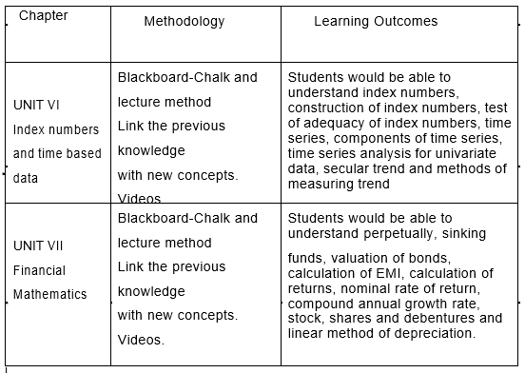

CURRICULAM: 2021-22
SUBJECT: PHYSICS
CLASS: XII
Learning objectives:
1. Strengthen the concepts developed at the secondary stage to provide frim foundation for further learning in the subject.
2. Expose the learner to different processes used in physics related industrial and technological application.
3. Develop process skills and experimental, observational, manipulative, decision making and investigatory skills in the learners.
4. Promote problem solving abilities and creating thinking in learners .
5. Develop conceptual competence in learners and make realize and appreciate the interface of physics with other disciplines.
MONTHS: APRIL
NO. OF WORKING DAYS: 23
CHAPTER | METHODOLOGY | LEARNING OUTCAME
UNIT-1 electrostatics | Lecture method/group  discussion | Would be able to familiar with electric charge and coulombs law and they would be able to calculate electrostatic force between static charges.  Would able to define electric field and understand its  significance and able to calculate electric field due to point  charges/group of point  charges/electric dipole would be able to visualize electric field lines due to point  charges/dipole/uniform field. Would able to define electric flux and its significance.  Would able to understand gauss law and apply it to calculate electric field due to thin charged sheet/due to charge distributed over a wire/electric field  inside/outside hollow sphere. Can understand the concept of electric potential and its reaction

with electric field.
Would able to calculate electric potential due to point
charge/group of charges/electric dipole.
Would able to define
capacitance of capacitor
and analyze energy
stored in parallel plate
capacitor. Would able to
analyse series/parallel
combination of capacitor
and energy stored in
capacitor able to
understand dielectric
and its polarization and
its effect on capacitance
of parallel plate
capacitor.
Would able to solve numerical problem on above
concepts.

MONTHS: MAY
NO. OF WORKING DAYS: 23
CHAPTER | METHODOLOGY | LEARNING OUTCAME
UNIT-2 current electricity | Lecture method/group  discussion/demonstration/personalized learning | Would be able to define electric current and can  distinguish between  current and electricity  understand why  current is scalar  quantity.  Would be able to define drift velocity, mobility and  able to establish  relation between  current and drift  velocity.  Would able to understand effect of temperature  on drift velocity.  Would able to interpret ohms

law and able to
distinguish between
resistance and
resistivity.
Would able to calculate
resistance of carbon
resistor using color
code.
Would able to analyse
series/parallel
combination of resistor
and observe their
application in daily life.
Would able to differentiate between terminal
voltage and EMF of cell
and able to understand
internal resistance of
cell and its dependence
on various factors.
Would able to understand krichoffs law and use it
to obtain balanced
condition of wheat
stone bridge.
Would able to measure
unknown resistance
using meter bridge.
Would able to
measure/compare EMF
of cell and internal
resistance of cell using
potential meter.
Develop problems solving skills on above said concepts.

MONTHS: JULY
NO. OF WORKING DAYS: 25
CHAPTER | METHODOLOGY | LEARNING OUTCAME
UNIT-3 magnetic effect of current and magnetism | Lecture  method/interactive/demonstration /PPT | Would able to understand concept of magnetic  field and conclusion of  orested experiment.  Can state biot-savert law and apply it find magnetic  field due to current  carrying circular loop.  Would able to state amperes law and use it to find  magnetic fied due to  infinitely lonf current  carrying  wire/solenoid/toroid.  Would able to find Lorenz  force/force on moving  charge in uniform  magnetic field.  Would able to understand working of cyclotron  and distinguish the role  of electric  field/magnetic field in  working cyclotron.  Would able to find force on current carrying  conductor in uniform  magnetic fid, force  between two parallel  current carrying long  conductors and able to  define one ampere.  Would able to find torque  experienced by current  loop in uniform  Magnetic field.  Would able to understand principle working of  moving coil  galvanometer able to  define current  sensitivity, voltage  sensitivity of moving coil  galvanometer and  conversion of MCG into  voltmeter/ammeter.  Would able to understand current loop as  magnetic dipole, its  magnetic dipole  moment, magnetic  dipole moment of  revolving electron,  magnetic field intensity  due to bar magnet along  its axis line/equation  line., torque on  magnetic dipole in  uniform magnetic field,  bar magnet as  equivalent solenoid,  magnetic field lines,  earth’s magnetic field  and magnetic elements.  Would able to distinguish  between dai, para and  ferro magnetic  substances.  Would able to select  material/substance  suitable for  electromagnet/paramag  net  Develop solving skills on above said concepts/topics.

MONTHS: AUGUST
NO. OF WORKING DAYS: 22
CHAPTER | METHODOLOGY | LEARNING OUTCAME
UNIT-4 EMI and AC | Lecture  method/interactive/demonstration/PPT | Would able to understand the concept of magnetic  flux, electro magnetic  induction, farday’s  law, induced current,  lenz law and eddy  current.  Would able to demonstrate self-induction/ mutual  induction.  Would able to understand concept of AC and  distinguish between  AC and DC.  Would able find relation between peak value  of current and rms  value of current.  Would able to understand

series LCR circuit,
resonance,
impendence,
reactance power
factor of AC circuits,
wattless current.
Would able to understand working of AC
generator and
transformer.
Would able to define
wavefront, state
huygen’s principle
and establish
refraction of light,
snells’s law using
hugyen principle.
Would able to understand interference of light,
young double slit
experiment fringes
fringe width coherent
sources of light
diffraction due to
single slit central
maxima
Would able to distinguish between interference
of light and
diffraction of light.
Understand polarization of light able to
demonstrate
polarization using
poloroid.
Would able to state
porewster’s law
Develop problem solving skills in above said
concept/topics

MONTHS: SEPTEMBER
NO. OF WORKING DAYS: 14
CHAPTER | METHODOLOGY | LEARNING OUTCAME
UNIT-5 EM waves  UNIT-7dual nature | Lecture method/interactive | Would able to understand basic idea of displacement  current, EM eaves,  production of EM waves  and their characteristics.  Would able to understand  electromagnetic  spectrum including  elementary about their  uses/production.  Would able to understand dual nature, photoelectric  effect, Einstein  photoelectric equation  and particle nature of  light.  Can state/understand de Broglie hypothesis, de broglie  waves, conclusion of  division geremer  experiment.

MONTHS: OCTOBER
NO. OF WORKING DAYS: 21
CHAPTER | METHODOLOGY | LEARNING OUTCAME
UNIT-6 optics | Lecture  method/demonstration/PPT | Would able to understand  concept of reflection of  light, spherical mirror,  concave mirror, convex  mirror, focus, focal  length, radius of  curvature, mirror  formula, linear  magnification.  Would able to understand the refraction of light and  distinguish between  refraction and reflection.  Can interpret snell’s law,  understand refraction  index.  Would able to demonstrate total  internal reflection and  observe its application in  daily life.  Would able to understand  refraction from spherical  refracting surfaces and  able to establish lens  maker formula and lens  formula and linear  magnification.  Would able to observe  combination of lenses in  daily life and understand  power of lens.  Would able to understand  concepts of refraction of  light and dispersion  through prism.  Would able to understand  working/magnifying  power of  telescope/microscope  and can distinguish  between them.

MONTHS: NOVMEMBER
NO. OF WORKING DAYS: 20
CHAPTER | METHODOLOGY | LEARNING OUTCAME
UNIT-8 atoms and nuclei  UNIT-9 electronic devices | Lecture method/interactive | Would able to  understand/interpret  Rutherford and particle  experiment and its  conclusion.  Would able to understand the bhor’s atom model,  energy level and  hydrogen spectrum and  able to calculate  wavelength  corresponding to various  series like lyman  paschan ets.  Would able to understand the

composition size of
nuclei, radioactivity.
Differentiate between alpha beta gamma decay and
can state radioactivity
decay law, half life,
decay constant.
Would able to interpret mass defect, bonding energy
and mass energy graph.
Distinguish between nuclear fission/fusion.
Develop problem solving skills on above said
concepts/topics.
Would able to distinguish
conductor, insulator and
semi conductor on the
basis of energy band
diagram.
Would able to distinguish
between n –type and p-
type semi conductor and
understand formation
PN junction.
Would able to forward bias and reverse bias of PN
junction and understand
their working.
Able to draw PI characteristics of PN junction diod in
forward biased and
reverse biased.
Would able to understand the working of PN junction
diod as half wave
rectifier and full wave
rectifier.
Would able to understand the working of jener diod,
LED, solar cell, etc.

MONTHS: DECMEBER
NO. OF WORKING DAYS: 25
CHAPTER | METHODOLOGY | LEARNING OUTCAME
UNIT- 8 and UNIT-9 – revision / pre-board 1 | Test/blackboard test/interactive method | Would able to access their preparation for board  exam.

MONTHS: JANUARY 2022
NO. OF WORKING DAYS:
CHAPTER | METHODOLOGY | LEARNING OUTCAME
pre-board 2 | Test exam | Would able to access their preparation for board exam.

CURRICULUM 2021-2022
SUBJECT CHEMISTRY
CLASS 12
OBJECTIVES
1 Promote understanding of basic facts and concepts of chemistry
2 Make students capable of studying chemistry in academic and professional courses
3 Expose the students to various emerging new areas of chemistry and apprise them with their relevance in future studies
4 Equip students to face various challenges related to health ,nutrition ,environment ,population ,weather, industries and Agriculture
5 Develop problem solving skills in students
6 Apprise students with the interface of chemistry with other disciplines of science such as Physics, Biology, engineering geology and mathematics
7 Acquaint students with different aspects of chemistry and its use in daily life
8 Develop an interest in students to study chemistry as a discipline
9 integrate life skills and values in context of chemistry
Month- April
Number of days-23
Chapter | Methodology | Learning outcomes
Solid state  Practical | Lecture method  Group Discussion  Video based learning  Art integrated learning  Crystallisation of Mohr's salt | Students will be able to:  - Describe general characteristics of solid state  - Distinguish between crystalline and amorphous solid  - Classify crystalline solids on the basis of of the nature of binding forces  - Define crystal lattice and unit cell  - Explain close packing of structures describe different types of voids and close packed structures  - Calculate the packing efficiency of different types of cubic unit cells  - Correlate the density of a substance with unit cell properties  - Describe the imperfections in solids and their effect on properties  - Correlate the electrical and magnetic properties of solids and their structures
Solutions  Practical | Lecture method  Group discussion  Activity based learning  Titration of potassium permanganate versus Mohr's salt  Titration of potassium permanganate versus oxalic acid | Students will be able to:  - Describe the formation of different types of solutions  - Express concentration of solutions in different units  - State and explain Henry's law and Raoults law  - Distinguish between ideal and non-ideal solution  - Explain deviations of real solutions from Raoults law  - Describe colligative properties of solutions and correlate with the molar masses of the solutes  - Explain abnormal colligative properties exhibited by some solutes in solution

Month- May
Number of days-23
Chapter | Methodology | Learning outcomes
Electrochemistry | Lecture method  PowerPoint presentation | Students will be able to:  - Describe an electrochemical cell and differentiate between Galvanic cell and electrolytic cell  Apply Nernst equation for calculating the EMF of electrochemical cell and define Standard potential  - Derive relation between Standard potential of the cell Gibbs energy of cell reaction and equilibrium constant.  - Define resistivity conductivity and molar conductivity of ionic solution  - Differentiate between ionic and electrolytic conductance  - Describe the method for measurement of conductivity of electrolytic solutions and calculation of their molar conductivity.  - Justify the variation of conductivity and molar conductivity of solutions with change in their concentration  - Enunciate the kohlrausch lawand its application  - Understand quantitative aspects of electrolysis  - Describe the construction of some primary and secondary batteries and fuel cells  - Explain corrosion as an electrochemical process
Chemical kinetics  Practical | Lecture method  Group discussion  Study the effect of change in concentration of sodium thiosulphate on rate of reaction | Students will be able to;  - Define the average and instantaneous rate of a reaction  - Express the rate of a reaction in terms of change in concentration of either of the reactants or products with time  - Distinguish between elementary and complex reactions  - Differentiate between the molecularity and order of a reaction  - Define rate constant  - Discuss the dependence of rate of a reaction on concentration temperature and catalyst  - Derive integrated rate equation for the zero and first order reactions  - Describe collision theory

Month: July
No.of days: 25
Chapter | Methodology | Learning outcomes
Surface chemistry  Practical | Lecture method  Demonstration  Group discussion  Preparation of lyophilic sol  Preparation of lyophobic sol  Paper chromatography | Students will be able to:  - Describe interfacial phenomenon and its significance  - Define adsorption and classify it into physical and chemical adsorption  - Explain mechanism of adsorption  - Explain the factors controlling the adsorption from gases and Solutions on solids  - Explain Freundlich adsorption isotherm  - Appreciate the role of catalysis in chemistry  - Enumerate the nature of colloidal state  - Describe preparation properties and purification of colloids  - Classify emulsions and describe their preparation and properties  - List the uses of colloids

Chapter | Methodology | Learning outcomes
Haloalkanes and haloarenes | Lecture method  Demonstrations of activities | Students will be able to:  - Name haloalkanes and haloarenes according to the IUPAC system of nomenclature  - Describe the reactions involved in preparation of haloalkanes and haloarenes and understand various reactions that they undergo  - Correlate the structure of Halo alkane and haloarenes with various types of reactions  - Use stereochemistry as a tool for understanding the reaction mechanism  - Highlight the Environmental effects of polyhalogen compounds

Chapter | Methodology | learning outcomes
Alcohols phenols and ethers  Practical | Lecture method  Demonstration of activities  Identification of functional group alcoholic and phenolic | Students will be able to:  - Name alcohols phenols and ethers according IUPAC system of nomenclature  - Discuss the reactions involved in the preparation of alcohols from alkanes and aldehydes ketones and carboxylic acid  - Discuss the reactions involved in preparation of phenols from halarenes benzene sulphonic acids diazonium salt and cumene  - Discuss the reactions for preparation of ethers from alcohols alkyl halides and sodium alkoxides  - Correlate physical properties of alcohols phenols and ethers with their structures  - Discuss chemical reactions of three classes of compounds on the basis of their functional groups

Month: August
No.of Days: 22
Chapter | Methodology | Learning outcomes
Aldehydes ketones and carboxylic acids  Practical | Lecture method  Demonstration of activities  Identification of aldehyde ketone and carboxylic group | Students will be able to:  - Write the common and IUPAC names of aldehydes ketones and carboxylic acids  - Write the structures of the compounds containing functional groups namely carbonyl and carboxyl group  - Describe the important methods of preparation and reactions of these classes of compounds  - Correlate physical properties and chemical reactions of aldehydes ketones and carboxylic acids with their structures  - Explain the mechanism of a few selective reactions of aldehydes and ketones  - Understand the various factors affecting the acidity of carboxylic acids and their reactions  - Describe the uses of aldehydes ketones and carboxylic acids
Amines  Practical | Lecture method demonstration method  Identification of Amine functional group | Students will be able to;  - Describe amines as derivatives of ammonia having a pyramidal structure  - Classify amines as Primary secondary and tertiary Amines write their IUPAC names  - Describe some important methods of preparation of amines  - Explain the properties of amines  - Distinguish between primary secondary and tertiary amines  - Describe the method of preparation of diazonium salts and their importance in the synthesis of series of aromatic compounds including azodyes
Biomolecules  Practical | Lecture method  Demonstration  Mind maps  Test for carbohydrates fats and proteins indifferent foodstuffs | Students will be able to  - Define the various molecules like carbohydrates proteins and nucleic acids  - Classify carbohydrates proteins nucleic acids and vitamins on the basis of their structures  - Explain the difference between DNA and RNA  - Appreciate the role of biomolecules in bio system

Month September
No. of days:14

Chapter | Methodology | Learning outcomes
General principles and processes of isolation of elements  Practical | Lecture method  Group discussion  Peer teaching  Identification of acidic and basic radicals | Students will be able to  - Explain the terms minerals ores concentration benefaction calcination and roasting refining etc  - Understand the principles of oxidation and reduction as applied to the extraction procedures  - Explain why specific reducing agents are used for the reduction purposes  - Write various steps involved in extraction of aluminium copper zinc and iron  - Appreciate the importance of metallurgy in industrial processes

Month October
No. of days 21

Chapter | Methodology | Learning outcomes
Coordination compounds  Practical | Lecture method  Group discussion  Identification of acidic and basic radical | Students will be able to  - Appreciate the postulates of werner's theory of coordination compounds  - Know the meaning of terms like coordination entity central atom ligand coordination number coordination sphere oxidation number homoleptic and heteroleptic complex  - Learn the rules of nomenclature of coordination compounds  - Write the formulas and names of mononuclear coordination compounds  - Define different types of isomerism of coordination compounds  - Understand the nature of bonding in coordination compounds in terms of valence bond theory and crystal field theory  - Appreciate the importance and applications of coordination compounds in our day to day life
The p block elements  Practical | Lecture method  Questioning and answering technique  Identification of acidic and basic radical | Students will be able to  - Appreciate general trends in chemistry of elements of group  15 16 17 and 18  - Learn the preparation properties and uses of dinitrogen and phosphorus and some of their important compounds  - Describe the preparation properties and uses of dioxygen and ozone and Chemistry of some of simple oxides  - Describe allotropic forms of sulphur chemistry of its important compounds and the structure of oxoacids  - Describe the preparation properties and uses of chlorine and hydrochloric acid  - Know the chemistry of interhalogens and structure of oxoacids of halogens  - Enumerate the uses of noble gases and appreciate the importance of these elements and their compounds in our daily life
Polymers | Lecture method  Group discussion  Peer teaching | Students will be able to  - Explain the terms monomer polymer and polymerization and appreciate their importance  - Distinguish between various classes of Polymers and different types of polymerization processes  - Appreciate the formation of polymers from mono and bi functional monomer molecules  - Describe the preparation of some important synthetic Polymers and their properties  - Appreciate the importance of polymers in daily life

Month: November
No. Of days: 20
Chapter | Methodology | Learning outcomes
The d and f block elements | Lecture method  Group discussion  Peer teaching | Students will be able to  - learn position of d and f block elements in the periodic table  - Know the electronic configuration of transition elements and inner transition elements  - Appreciate the relative stability of various oxidation states in terms of electrode potential values  - Describe the preparation properties structures and uses of some important compounds like potassium dichromate and potassium permanganate  - Understand the general characteristics of d and f block elements and their general horizontal and group ttends  - Describe the properties of the F block elements and give comparative account of lanthanides and actinoids with respect to their electronic configuration Oxidation state and chemical behaviour
Chemistry in everyday life | Lecture method  Group discussion | Students will be able to  - Visualise the importance of Chemistry in daily life  - Explain the term chemotherapy  - Describe the basis of classification of drugs  - Explain drug target interaction of enzymes and receptors  - Explain how various types of drugs function in the body  - Know about artificial sweetening agents and food preservatives  - Discuss the chemistry of cleansing agents

Month: December
No.of working days:25

Revision
Practice test
Month January
No. Of days: 16

Revision
Pre board exams

Month:Feburary
No of days:15

Revision
Practicals for boards

CURRICULAM 2021-22
SUBJECT- BIOLOGY
CLASS- XII

LEARNING OBJECTIVES-
1- Define basic biological concepts and processes.
2- Describe levels of organization and related functions in plants and animals.
3- Describe the intricate relationship between various cellular structures and their corresponding functions.
4- Demonstrate critical thinking skills.
MONTH –APRIL NO. OF WORKING DAYS- 23

CHAPTER | METHODOLOGY | LEARNING OUTCOMES
1. Reproduction in Organisms | - Demonstration and Lecture method  - Pupil centered method (inside the class) | - Acquire the concept of internal and external fertilization.  - Concept of seed and fruit formation will be developed.  - Will acquire the concept of various Vegetative propagation and their types.
2. Sexual Reproduction in Flowering Plants. | - Demonstration and Lecture method  - Pupil centered method (inside the class) | - Acquire the knowledge to identify various flowers pollinated by various agencies.  - Development of special modes of fruit formation and its key concepts.  - Concept of endosperm formation and its importance.
3- Human Reproduction | - Demonstration and Lecture method  - Pupil centered method (inside the class) | - Students will be able to understand the concept of spermatogenesis and oogenesis and various hormonal changes occurring during it.  - Will know the various stages of implantation and its affect on uterus.  - Role of placenta and placental hormones during pregnancy.

MONTH –MAY NO. OF WORKING DAYS- 23

CHAPTER | METHODOLOGY | LEARNING OUTCOMES
3- Human Reproduction (CONTD.)
4-Reproductive Health | - Demonstration and Lecture method  - Pupil centered method (inside the class) | - Students will be aware of various methods which are developed to combat infertility.  - Use of contraceptions and their effect on body
CHAPTER | METHODOLOGY | LEARNING OUTCOMES
5- Principles of Inheritance and Variations | - Demonstration and Lecture method  - Pupil centered method (inside the class) | - Concept building on mendelian genetics.  - Various attributes of mendelian and chromosomal disorders.  - Blood groups and their role in various organisms.  - Role of mutation and its affect can be studied.  - . Family diseases can be studied with the help of pedigree analysis chart.
MONTH - JULY NO. OF WORKING DAYS- 25

CHAPTER | METHODOLOGY | LEARNING OUTCOMES
6-Molecular Basis of Inheritance | - Demonstration and Lecture method  - Pupil centered method (inside the class) | - Concept of DNA and its structure is developed.  - DNA packaging and its applications.  - Genetic code and its relation with protein synthesis.
7- Evolution | - Demonstration and Lecture method  - Pupil centered method (inside the class) | - Concept building on various theories of evolution  - Knowledge about evolution ,its patterns and evidences of evolution  - Strategies of hardy Weinberg principle.  - Deviations from Hardy Weinberg principle.  - Knowledge of evolution of plants and animals.
8-Human Health and Diseases | - Demonstration and Lecture method  - Pupil centered method (inside the class) | - Knowledge of how diseases are spread will be developed.  - Concept of personal hygiene and its importance will be developed.  - Drugs and misuse will be administered.

MONTH - AUGUST NO. OF WORKING DAYS- 22

CHAPTER | METHODOLOGY | LEARNING OUTCOMES
9-Strategies for Enhancement of Food Production | - Demonstration and Lecture method  - Pupil centered method (inside the class) | - Different strategies of food production will be known  - Strategies for food production and hybridization  - Importance of animal husbandry
10-Microbes in Human Welfare | - Demonstration and Lecture method  - Pupil centered method (inside the class) | - Know the importance of microbes in day to day life.  - Role of antibiotics, its use and its manufacture.  - Role of microbes an biocontrol agents.
MONTH - SEPTEMBER NO. OF WORKING DAYS- 14

CHAPTER | METHODOLOGY | LEARNING OUTCOMES
10- Microbes in Human Welfare (CONTD.) & Revision | - Demonstration and Lecture method  - Pupil centered method (inside the class) | - The learner will by now honed the skills and habit of recapitulation.  - Plan a revision course for better implementation of lessons learnt  - Develop a confidence in approaching Examination
MONTH - OCTOBER NO. OF WORKING DAYS- 21

CHAPTER | METHODOLOGY | LEARNING OUTCOMES
11-Biotechnology : Principles and  Processes | - Demonstration and Lecture method  - Pupil centered method (inside the class) | The students will be able to –  - Know the concept of biotechnology and its applications.  - How this can be used in different methodologies  - Formation and implications of rDNA
12-Biotechnology and Its Application | - Demonstration and Lecture method  - Pupil centered method (inside the class) | The students will be able to understand the  - concept of gene therapy and its applications in various diseases  - The use of various GMOs and their benefit to organisms.
13- Organisms and Populations. | - Demonstration and Lecture method  - Pupil centered method (inside the class) | The students will be able to-  - Relate the various kinds of population interactions  - Population characteristics and its estimation will be known.  - Concept of habitat and niche will be broadened.
MONTH - NOVEMBER NO. OF WORKING DAYS- 20

CHAPTER | METHODOLOGY | LEARNING OUTCOMES
14- Ecosystem | - Demonstration and Lecture method  - Pupil centered method (inside the class) | The students will be able to understand-  - The concept of primary and secondary productivity will be developed.  - Ecological succession and its application  - Nutrient cycling and its impact on environment.  - Energy flow and its estimation via 10% law
15- Biodiversity and its Conservation | - Demonstration and Lecture method  - Pupil centered method (inside the class) | The students will be able to-  - Differentiate between various conservation strategies.  - Knowledge of red data book will be enhanced.  - Identification of biodiversity hot spots
16-Environmental issues | - Demonstration and Lecture method  - Pupil centered method (inside the class) | - The students will be able to-  - Know the various kinds of wastes and their modes  of disposal.  - Green house Effect and its impact.  - Management of radioactive wastes.
MONTH - DECEMBER
NO. OF WORKING DAYS- 25
REVISION and PERIODIC II
MONTH-JANUARY (16)days | PRACTICE EXAM II
MONTH- FEBRUARY (15)days | BOARD EXAMS
MONTH-MARCH | BOARDEXAMS

DAV PUBLIC SCHOOL BRIJ VIHAR GHZ UP
CURRICULUM 2021-22 CLASS12
ECONOMICS

Learning Objectives:

Understanding of some basic economic concepts and development of economic reasoning which learners can apply in day to day life.

Realisation of learners role in Nation building.

Equipment with basic tools of economics to analyse economic issues.

Development of understanding that there can be more than one view on any economic issue and necessary skills to argue logically with reasoning.

Number of working days April 2021 - 23 days

TOPIC | METHODOLOGY | LEARNING OUTCOMES
Development Policies And Experience (1947-1990)  Indian Economy On The Eve Of Independence | To Familiarise the students about the state of the Indian Economy in 1947  Write the bullet points on the black board and discuss all the points in class  Factors that led to the underdevelopment and stagnation of the Indian Economy will be asked from students and they will be asked to make a flow chart of it | Understanding the economy before independence  British policies were more with the protection and promotion of British economic interests .  The rule of British India govt led to collapse of Indian agriculture ,industry  At the time of independence the social and Economic challenges before the country were large.
Indian Economy 1950-1990 | Economic system that Indian Economy adopted will be discussed in class  Economic planning and its objectives will be explained using blackboard  Goals of five year planning will be explained using flow chart  Green Revolution in agriculture sector will be discussed and how it helped India to become self-sufficient in food grain production.  Various policies will be explained which raised contribution of industrial sector in GDP.  Concept of inward looking trade policy will be discussed and strategy of import substitution and export promotion will be explained | After Independence India adopted Mixed Economic  system  All economic planning is done through five year plans.  Dependence on agriculture was very large .  Main policy measures in Agriculture were green revolution and land reforms.  The Main drawback in industrial sector was insufficient functioning of the public sector  Our ponies were inward oriented and so we failed to develop strong export sector.
Economic Reforms since 1991 | Relating previous chapters with this chapter discussing the condition of the Indian Economy due to which economic reforms were introduced  The mechanism will be discussed through reforms will be introduced  Elements of NEP will be explained through flow charts  Real life Indian economic egs will be taken to explain the reforms introduced during liberalization, Globalisation,  demonetisation and GST | India was facing an economic crisis due to which NEP was adopted  Many domestic reforms were introduced in industrial and financial sector  Role of Public sector was reduced and many private sector companies were given chance  Outsourcing emerged as business activity.  Reasons for demonetization and GST and how far it impacted Economics.

Number of working days in May 2021 - 23 days

Current Challenges facing Indian Economy  POVERTY | Meaning of Poverty will be explained connecting it with unemployment  Students will be asked various reasons of poverty and flow diagram will be made to chalk out all reasons  Various reasons of rural poverty and urban poverty will be taken up by Connecting them to real life situations faced by our economy  Students will be asked to find out various initiatives taken by Govt to reduce poverty and they will be discussed in class  Impact of covid19 on poverty will also be taken up in class | Major challenge faced by Indian economy is poverty  Differentiate between Absolute and Relative poverty  Comprehend the diverse dimensions relating to the concept of poverty  To assess how far the poverty alleviation programs have been able to solve the problem of poverty  Need to create more employment our country
HUMAN CAPITAL FORMATION | Meaning of Human Capital will be explained by discussing role of factors of production  Discussion on similarities between physical capital and human capital will be discussed in the class  Students will be asked how human capital formation takes place  Flow chart on sources of Human Capital will be made on the back Board and students will be asked to talk about them.  A relation ship of Human capital with Human Development and Economic growth will be explained by taking examples  A discussion on what needs to be done by Govt to Improve Human capital formation will be done with students and suggestions will be asked from them | Understand the meaning of Human Capital and Physical Capital  Differentiate between Human capital Human development  How Human Capital formation can be improved in India  What are the steps taken by the Govt to Improve human capital formation

NOTE:
Project work will be discussed in the class and the guidelines will be given to students to complete the project work during summer vacations.

Number of working days July 2021 - 25 days

TOPIC | METHODOLOGY | LEARNING OUTCOMES
RURAL DEVELOPMENT | Initially the condition of the rural sector will be discussed with the students  A flow chart will be made on the important features of rural sector in our country  as suggested by students  Rural Development in India  Infrastructure  Rural credit  Agriculture Marketing  Warehousing facilities  Insurance and risk management  All these will be taken up by help of case studies  Students will be asked about new development avenues in rural areas | Enable to explain the term rural development  Chalk out the features of rural development in India  Suggest measures to Improve condition of rural development through  infrastructure development  Improving rural credit, marketing facilities, warehousing facilities  The students will be able to suggest various avenues to improve condition of rural sector
EMPLOYMENT-GROWTH INFORMALISATION AND OTHER ISSUES | Explain the basic concept related unemployment  Students will be given examples to differentiate between worker workforce and unemployment  Different types of unemployment will be explained by siting various examples to students  Case studies will be taken up on govt initiative on generating employment  Initiative taken by the Govt during the situation of covid19 to generate employment | Understand a few basic concepts relating to employment  Relate the concept of worker ,workforce and unemployment  Explain the nature of participation of men and women in various  economic activities  Know the nature and extent of unemployment in India  To analyse the initiative taken by Govt to generate employment in various sectors of the economy.
INFRASTUCTURE | Few examples will be taken up in class to explain the concept of economic and social infrastructure  Flow chart will be used to explain the relevance of infrastructure  Various sources of energy will be discussed in class and students will be asked to showcase the sources of energy through Art Integration  Problems faced by the health sector will be taken up and will be discussed with students  Solution to the Problems faced by health sector will be asked from the students | Differentiate between economic and social infrastructure  Understand the main challenges India faces in the area of social and economic infrastructure  Interconnect the role of infrastructure with economic development  Understand the role of energy and health as a critical component of infrastructure  Chalk out the problems faced by energy and health sector  Critically appraise the problems of health and energy in India
ENVIRONMENT AND SUSTAINABLE DEVELOPMENT | Topic will be started with egg of Biotic and Abiotic elements of environment  Students will be asked examples for the same  Flow chart will be used to relate growth with degradation of environment  Strategy of sustainable development will be discussed and students views will be asked on the issue | Understand the concept of Environment  Chalk out the causes and effect of environmental degradation and resource depletion  Understand the Environmental challenges faced by India  Enable to relate environmental issues to the larger context of sustainable development

Number of working days August 2021 - 22 days

TOPIC | METHODOLOGY | LEARNING OUTCOMES
INDIA AND ITS  NEIGHBOURS  :DEVELOPMENT EXPERIENCE | Discussing the latest scenario with students about relation of India with China and Pakistan  Students will be told how not only India struggled in its journey of independence but also China and Pakistan also did the same  Historical path of all 3 countries will be taught with the help of table mentioning various indicators in the table  Comparative study of all 3 countries will be done using data and case studies | Enable students to comprehend the history of development of 3 nations  Chalk out the struggles faced by the 3 country's in their path of development  Enable them to compare the development indicators of the 3 countries and conclude which country is in the best position
MACRO ECONOMIC THEORY  NATIONAL INCOME AND RELATED AGGREGATES | Starting by relating micro with macro Economics  Taking examples to explain the concept of macroeconomics  Using black board to differentiate between micro macro economics in tabular form  Meaning of various NI concepts will be explained with help of examples  Diagrams will be used to explain the topic of real flow and money flow  Basic National Income Aggregates will be explained by formulating formulas on black board  All the three methods of measuring National Income will be done through numerical examples on black board  Concept of real and nominal GDP will be explained relating it to NI At constant and current prices | Differentiate between micro macro economics  Site examples on micro and macro economics  Enable them to draw circular flow of national income  Students will be able to formulate the national income formulas  Enable them to solve the numerical based on the three methods  Differentiate between real and nominal GDP
Number of working days September 2021 - 14 days

TOPIC | METHODOLOGY | LEARNING OUTCOMES
MONEY AND BANKING | Starting the chapter by discussing about medium of exchange during historical time till British period  Asking students about drawbacks of bater system over money system  Prompting students to tell about functions of money  Asking students what are the components of Money Supply  Taking numerical example the concept of credit creation by commercial banks will be explained  Functions of central banks will be taken up and day to day examples will be taken up to explain the concept | Chalk out draw backs of barter system  Explain functions of money  Name the components of money supply  Enable them to numerically explain credit creation by commercial banks  Enable the students to chalk out steps taken by the central banks to control situation of money supply in the economy
Revision for Half Early

Number of working days October 2021 - 21 days

TOPIC | METHODOLOGY | LEARNING OUTCOMES
GOVERNMENT BUDGET AND THE ECONOMY | Meaning of govt budget will reexplained in line with budget made by a family  Objectives of budget will be explained with lecture method  Flow chart will be used for explaining components of budget  Various examples will be given to students to classify them into various categories  Types of budget will be taken up and various types of deficit in the budget will be discussed  Numerical examples will be taken up to explain how to calculate deficit in the budget | Student will be able to understand why budgeting for a govt is important  Enable them to classify various budget receipts and expenditures into budget receipts and expenditures  Enable students to calculate deficit in the budget
BALANCE OF PAYMENT AND FOREIGN EXCHANGE RATE | Taking example of goods traded outside and purchased will be used to explain concept of BOP  Flow chart will be used to explain components of BOP  Using components BOP current A/C and capital A/C will be explained  Students will be prompted to give reasons for disequilibrium in BOP and measures will be discussed  Students will be given a situation where they had to purchase goods from abroad taking this as a base foreign exchange rate will be explained  Using diagram determination of foreign exchange rate will be explained  Comparative study of various exchange rates will be done using table on blackboard | Define meaning of BOP  Chalk out the components of BOP  Differentiate the concept of current and capital A/C  Give reasons for disequilibrium in BOP  Draw diagram how exchange rate is determined by DD and SS factors  Differentiate between fixed and flexible exchange rate

Number of working days November 2021 - 20 days

TOPIC | METHODOLOGY | LEARNING OUTCOMES
DETERMINATION OF INCOME AND EMPLOYMENT | Students will be familiarize with concepts of AD and AS relating to demand and supply  Components of AD will be taken up using equation and diagram (consumption function, saving function and Investment function)  Derivation of consumption curve from saving curve will be explained by drawing it on black board  National Income level and Equilibrium level of income through saving and Invt and AD and AS approach will be explained using schedule and diagram  Investment Multiplier will be explained by taking numerical example and diagram  Excess Demand/Inflationary gap and Deficient Demand/Deflationary gap will be explained using diagram  Numericals on equilibrium level of Income consumption, saving and investment will be explained on the black board | Understand the meaning of AD and AS  Students will be able to write equation of AD and AS and draw the curves for consumption saving and invt  Students will be able to do numerical based on APC APS MPC MPS  Students will be able to locate equilibrium level of income by S and I approach and AD and AS approach  Numerically calculate Y, C, I ,S Multiplier and locate all on the diagram also

December 2021:

Determination of Income and Employment will be continued for a week and for the rest of the days revision for practice examination.

January 2022:
Sample question paper will be discussed and another practice exam will be taken.

Curriculum 2021-22
Subject: Accountancy
Class: XII

Learning Objectives
1.To familiarize students with new and emerging areas in the preparation and presentation of financial statements.
2. To acquaint students with basic accounting concepts and accounting standards.
3. To develop the skills of designing need-based accounting database.
4. To appreciate the role of ICT in business operations.
5. To develop an understanding about recording of business transactions and preparation of financial statements.
6. To enable students with accounting for Not-for-Profit organizations, accounting for Partnership Firms and company accounts

Month & No. of working Days: April, 23 Days
To acquaint students with basic accounting concepts and accounting standards.

Chapter | Methodology | Learning
Part-B  Unit 4-Analysis of Financial Statement | Mind Maps  Story Telling | After going through this Unit, the students will be able to:  • develop the understanding of major headings and sub-headings (as per Schedule III to the Companies Act, 2013) of balance sheet as per the prescribed norms / formats.  • state the meaning, objectives and limitations of financial statement analysis.  • discuss the meaning of different tools of 'financial statements analysis'.  • develop the understanding and skill of preparation of comparative and common size financial statements.  • state the meaning, objectives and significance of different types of ratios.  • develop the understanding of computation of current ratio and quick ratio.  • develop the skill of computation of debt equity ratio, total asset to debt ratio, proprietary ratio and interest coverage ratio.  develop the skill of computation of inventory turnover ratio, trade receivables and trade payables ratio and working capital turnover ratio.  • develop the skill of computation of gross profit ratio, operating ratio, operating profit ratio, net profit ratio and return on investment.

Month & No. of working Days: May, 23 Days
Chapter | Methodology | Learning
Unit 5- Cash Flow Statement | Mind Maps  Story Telling | After going through this Unit, the students will be able to:  • state the meaning and objectives of cash flow statement.  • develop the understanding of preparation of Cash Flow Statement using indirect method as per AS 3 with given adjustments.
Project Work

Month & No. of working Days: July, 25 Days
Chapter | Methodology | Learning
Part-A  Unit 3- Accounting for Companies | Mind maps  Story telling  Role Play | After going through this Unit, the students will be able to:  • state the meaning of share and share capital and differentiate between equity shares and preference shares and different types of share capital.  • understand the meaning of private placement of shares and Employee Stock Option Plan.  • explain the accounting treatment of share capital transactions regarding issue of shares.  • develop the understanding of accounting treatment of forfeiture and re-issue of forfeited shares.  • describe the presentation of share capital in the balance sheet of the company as per schedule III part I of the Companies Act 2013.  • explain the accounting treatment of different categories of transactions related to issue of debentures. • develop the understanding and skill of writing of discount / loss on issue of debentures.  • understand the concept of collateral security and its presentation in balance sheet. • develop the skill of calculating interest on debentures and its accounting treatment.  state the meaning of redemption of debentures.  • develop the understanding of accounting treatment of transactions related to redemption of debentures by lump sum, draw of lots and Creation of Debenture Redemption Reserve.

Month & No. of working Days: August, September, October, (57 Days)
Chapter | Methodology | Learning
Part-A  Unit 2- Accounting for Partnership Firms | Mind maps  Story telling  Role play | After going through this Unit, the students will be able to:  • state the meaning of partnership, partnership firm and partnership deed.  • describe the characteristic features of partnership and the contents of partnership deed.  • discuss the significance of provision of Partnership Act in the absence of partnership deed.  • differentiate between fixed and fluctuating capital, outline the process and develop the understanding and skill of preparation of Profit and Loss Appropriation Account.  • develop the understanding and skill of preparation profit and loss appropriation account involving guarantee of profits. • develop the understanding and skill of making past adjustments.  • state the meaning, nature and factors affecting goodwill • develop the understanding and skill of valuation of goodwill using different methods.  • state the meaning of sacrificing ratio, gaining ratio and the change in profit sharing ratio among existing partners.  • develop the understanding of accounting treatment of revaluation assets and reassessment of liabilities and treatment of reserves and accumulated profits by preparing revaluation account and balance sheet.  • explain the effect of change in profit sharing ratio on admission of a new partner.  • develop the understanding and skill of treatment of goodwill, treatment of revaluation of assets and re-assessment of liabilities, treatment of reserves and accumulated profits, adjustment of capital accounts and preparation of balance sheet of the new firm.  • explain the effect of retirement / death of a partner on change in profit sharing ratio.  • develop the understanding of accounting treatment of goodwill, revaluation of assets and re-assessment of liabilities and adjustment of accumulated profits and reserves on retirement / death of a partner and capital adjustment.  • develop the skill of calculation of deceased partner's share till the time of his death and prepare deceased partner's executor's account.  • discuss the preparation of the capital accounts of the remaining partners and the balance sheet of the firm after retirement / death of a partner.  • understand the situations under which a partnership firm can be dissolved.  • develop the understanding of preparation of realisation account and other related accounts.

Month & No. of working Days: November, 20
Chapter | Methodology | Learning
Part-A  Unit 1- Financial Statement of Non-for-Profit Organizations | Mind maps  Story telling | After going through this Unit, the students will be able to:  • state the meaning of a Not-for-profit organisation and its distinction from a profit-making entity.  • state the meaning of receipts and payments account and understanding its features.  • develop the understanding and skill of preparing receipts and payments account.  • state the meaning of income and expenditure account and understand its features.  • develop the understanding and skill of preparing income and expenditure account and balance sheet of a not-for-profit organisation with the help of given receipts and payments account and additional information.

Month & No. of working Days: December, January, February, 56 Days
- Revision of chapters and discussion on previous 5 years question papers (CBSE)

Curriculum 2021-22
Subject: Business Studies
Class: XII

Learning Objectives
- To inculcate business attitude and develop skills among students to pursue higher education, world of work including self-employment.
- To develop students with an understanding of the processes of business and its environment;
- To acquaint students with the dynamic nature and inter-dependent aspects of business;
- To develop an interest in the theory and practice of business, trade and industry;
- To familiarize students with theoretical foundations of the process of organizing and managing the operations of a business firm;
- To help students appreciate the economic and social significance of business activity and the social cost and benefits arising there from;
- To acquaint students with the practice of managing the operations and resources of business;
- To enable students to act more effectively and responsibly as consumers, employers, employees and citizens

Month & No. of working Days: April, 23 Days
Chapter | Methodology | Learning
Part-B  Unit-11- Marketing management | Mind Maps, storytelling, Case studies & Role Play | After going through this Unit, the students will be able to:  • Understand the concept of marketing.  • Explain the features of marketing.  • Discuss the functions of marketing.  • Explain the marketing philosophies.  • Understand the concept of  marketing mix.  •Describe the elements of marketing  mix.  •Understand the concept of product as an element of marketing mix.  • Understand the concept of branding, labelling and packaging.  • Understand the concept of price as an element of marketing mix.  • Describe the factors determining price of a product.  • Understand the concept of physical distribution.  • Explain the components of physical distribution.  • Describe the various channels of distribution.  • Understand the concept of promotion as an element of marketing mix.  • Describe the elements of promotion mix.  • Understand the concept of advertising.  • Understand the concept of sales promotion.  • Discuss the concept of public relations.
Unit-12- Consumer protection | Mind Maps, storytelling, Case studies & Role Play | • Understand the concept of consumer protection.  • Describe the importance of consumer protection.  • Discuss the scope of Consumer Protection Act, 2019 Understand the concept of a consumer according to the Consumer Protection Act, 2019.  • Explain the consumer rights • Understand the responsibilities of consumers  • Understand who can file a complaint and against whom? • Discuss the legal redressal machinery under Consumer Protection Act, 2019.  • Examine the remedies available to the consumer under Consumer Protection Act, 2019 Describe the role of consumer organizations and NGOs in protecting consumers’ interests.

Month & No. of working Days: May, 23 Days
Chapter | Methodology | Learning
Part-B  Unit-9 Financial Management | Mind Maps, storytelling, Case studies & Role Play | After going through this Unit, the students will be able to:  • Understand the concept of financial management.  • Explain the role of financial management in an organisation.  • Discuss the objectives of financial management Discuss the three financial decisions and the factors affecting them. • Describe the concept of financial planning and its objectives.  • Explain the importance of financial planning. Understand the concept of capital structure.  • Describe the factors determining the choice of an appropriate capital structure of a company.  • Understand the concept of fixed and working capital.  • Describe the factors determining the requirements of fixed and working capital.
Unit-10 Financial Market | Mind Maps, storytelling, Case studies & Role Play | • Understand the concept of financial market.  • Explain the functions of financial market.  • Understand capital market and money market as types of financial markets.  • Understand the concept of money market.  • Describe the various money market instruments.  • Discuss the concept of capital market.  • Explain primary and secondary markets as types of capital market.  • Differentiate between capital market and money market.  • Discuss the methods of floating new issues in the primary market.  • Distinguish between primary and secondary markets Give the meaning of a stock exchange.  • Explain the functions of a stock exchange.  • Discuss the trading procedure in a stock exchange. • Give the meaning of depository services and demat account as used in the trading procedure of securities. State the objectives of SEBI.  • Explain the functions of SEBI.
Project Work

Month & No. of working Days: July, 25 Days
Chapter | Methodology | Learning
Part-A  Unit-1 Nature and significance of management | Mind Maps & Role Play | After going through this Unit, the students will be able to:  • Understand the concept of management.  • Explain the meaning of ‘Effectiveness and Efficiency.  • Discuss the objectives of management.  • Describe the importance of management.  • Examine the nature of management as a science, art and profession. Understand the role of top, middle and lower levels of management  • Explain the functions of management Discuss the concept and characteristics of coordination.  • Explain the importance of coordination
Unit-2 Principles of management | Mind Maps & Role Play | • Understand the concept of principles of management.  • Explain the significance of management principles.  • Discuss the principles of management developed by Fayol. Explain the principles and techniques of ‘Scientific Management’.  • Compare the contributions of Fayol and Taylor.

Month & No. of working Days: August, 22 Days
Chapter | Methodology | Learning
Part-A  Unit-3 Business Environment | Mind Maps, storytelling, Case studies | After going through this Unit, the students will be able to:  • Understand the concept of ‘Business Environment’.  • Describe the importance of Business Environment  • Describe the various dimensions of ‘Business Environment’.  • Understand the concept of Demonetization Examine the impact of government policy changes on business in India with reference to liberalisation, privatization and globalisation since 1991.  • Discuss the managerial response to changes in business environment.
Unit-4 Planning | Mind Maps, Role Play, Case studies | • Understand the concept of planning.  • Describe the importance of planning.  • Understand the limitations of planning.  • Describe the steps in the process of planning.  •Develop an understanding of single use and standing plans. • Describe objectives, policies, strategy, procedure, method, rule, budget and programme as types of plans.

Month & No. of working Days: September, 14 Days
Chapter | Methodology | Learning
Part-A  Unit 5- Organizing | Mind Maps, storytelling | After going through this Unit, the students will be able to:  • Understand the concept of organizing as a structure and as a process.  • Explain the importance of organising. Describe the steps in the process of organising.  • Describe functional and divisional structures of organisation.  • Explain the advantages, disadvantages and suitability of functional and divisional structure.  • Understand the concept of formal and informal organisation.  • Discuss the advantages and disadvantages of formal and informal organisation. Understand the concept of delegation.  • Describe the elements of delegation.  • Appreciate the importance of delegation. Understand the concept of decentralisation.  • Explain the importance of decentralisation.  • Differentiate between delegation and decentralisation.

Month & No. of working Days: October & November, 41 Days
Chapter | Methodology | Learning
Part-A  Unit 6- Staffing | Mind Maps, storytelling, Role Plays & Case studies | After going through this Unit, the students will be able to:  • Understand the concept of staffing.  • Explain the importance of staffing  • Understand the specialized duties and activities performed by Human Resource Management  • Describe the steps in the process of staffing Understand the meaning of recruitment.  • Discuss the sources of recruitment. Explain the merits and demerits of internal and external sources of recruitment. Understand the meaning of selection.  • Describe the steps involved in the process of selection. Understand the concept of training and development.  • Appreciate the importance of training to the organisation and to the employees.  • Discuss the meaning of induction training, vestibule training, apprenticeship training and internship training.  • Differentiate between training and development.  • Discuss on the job and off the job methods of training.
Unit 7 Directing | Mind Maps, storytelling, Role Plays & Case studies | • Describe the concept of directing.  • Discuss the importance of directing Describe the various elements of directing Understand the concept of motivation.  • Develop an understanding of Maslow’s Hierarchy of needs.  • Discuss the various financial and non-financial incentives. Understand the concept of leadership.  • Discuss the various styles of leadership. Understand the concept of communication  • Understand the elements of the communication process.  • Discuss the concept of formal and informal communication.  • Discuss the various barriers to effective communication.  • Suggest measures to overcome barriers to communication.
Unit-8 Controlling | Mind Maps, storytelling, Role Plays & Case studies | • Understand the concept of controlling.  • Explain the importance of controlling -Describe the relationship between planning and controlling -Discuss the steps in the process of controlling

Month & No. of working Days: December, January & February, 56 Days
- Revision of chapters and discussion on previous 5 years question papers (CBSE)

CURRICULUM 2021-22

Subject- Physical Education
Class- XII
Learning Objectives-
- Creating new knowledge
- Developing feelings and emotions
- Enhancing physical and mental skills
Month (and Number of days) - April to November (148 days)

April to May (46 days)
S No. | Chapter | Methodology | Learning Outcomes
1 | Planning in sports | - Lecture method  - Chalk & Board  - Instructional method  - Discussion method | Planning is important to conduct a successful competition.
2 | Sports and nutrition | - Lecture method  - Discussion method | Importance of balanced diet and nutrition for body.

July to August (47 days)
S No. | Chapter | Methodology | Learning Outcomes
3 | Yoga and lifestyle | - Lecture method  - Instructional method  - Discussion method | Asanas as preventive measures.
4 | Physical education and sports for CWSN | - Lecture method  - Discussion method | To understand the concept of disability and disorder.
5 | Children and women in sports | - Lecture method | Motor development and factors affecting it.

September to October (35 days)
6 | Test and measurement in sports | - Lecture method  - Demonstration method | Need and importance of test and measurement in sports.
7 | Physiology and injuries in sports | - Lecture method  - Discussion method | Physiological factors determining components of physical fitness.
8 | Biomechanics and sports | - Lecture method  - Instructional method | Importance of biomechanics in sports.
November (20 days)
9 | Psychology in sports | - Lecture method  - Discussion method | Role of psychology in sports performance.
10 | Training in sports | - Lecture method  - Discussion method | Different training programmes for physical fitness.

Subject : Music Vocal
Class: XII
Learning Objectives:-
- Learn Vocal Music
- Short and Long Definitions in Hindi and English

CONTENT | METHODOLOGY | LEARNING OUTCOME
April:- 28 Periods;  Brief study of the following definitions. Alankar, Kan, Meend, Khatka, etc.  Practical:- Raag Bharav Dhrut Khyal | Lecture Method and given some short questions.  Memorizing the Raag. | Students learned short definitions.  Developing singing skills
May:- 26 Periods;  Long definitions and introduction to Raag Bharav, Malkauns, Raag Bageshri.  Practical:- Aalap and Taan in Raag Bharav | Lecture Method and write Raag Bharav notation.  Aalap and Taan in Raag Bharav. | Students know how to write notation of Raag.  Honing the singing skills.
July:- 25 Period;  Historical development of Time theory of Raagas  Practical:- Rupak Taal with hand beats. | Lecture Method.  All Taalas with hand beats – Thah, Dugun, Chaugun. | Students learned how to divide time of Raagas  Honing the Taal skills.
August:- 22 Periods;  Detail study of Sangeet Ratnakar and Sangeet Parijaat  Practical:- Raag Malkauns and Raag Bageshri. | Lecture Method.  Write complete descriptions and their importance.  Taan and Aalap. | Students came to know the importance of these books.  Developing rythematic sense.
September:- 14 Periods;  Life sketch and contribution of musicians.  Practical:- Tarana or Dhamaar | Lecture Method.  Students wrote life sketches of vocalists and their works.  Laykari – Thah, Dugun and Chaugun. | Students collected their photographs and learned how to improve classical music.  Developing the sense of Sur and Taal.
October:- 21 Periods;  Taalas along with Taal notations.  Practical:- Dhamaar Taal with Laykari. | Lecture Method.  Write Taala notations.  Learn Taal with hand beats. | Students will know how to write Laykari.  Developing the sense of Taal Beats.
November:- 20 Periods;  Tuning of Tanpura.  Practical: - Playing of Tanpura. | Lecture and Demo Method. | Students learned the basic knowledge of Classical Music by Tanpura.
December:- 25 Periods;  Recognizing of Raagas.  Practical: Identification of Raagas. | Lecture and Demo Method. | Students will be able recognize the Raagas and their Swar.
January:- 16 Periods;  Revision of full syllabus | More practise for perfection. | Students prepared themselves for theory and practical examination.
February:- 15 Periods;  Preparations for Practical and Theory Examination. | More practise for perfection. | Garnished the Vocal Music subject.

Curriculum – 2021-2022
SUB- FINE ARTS
CLASS- 12TH

LEARNING OBJECTIVES -
- The objective of including the history of Indian arts for the student is to familiarize them with the various styles and modes of art expressions from different parts of India. This would enrich their vision and enable them to appreciate and develop an aesthetic sensibility to enjoy the beauty of nature and life. The students will also have an opportunity to observe and study the evolution of its mutations and synthesis with other style an altogether new style. The students should be made aware of art as human experience. The teacher should be able to expose them to the wide range of artistic impressions, the media, the tool used. The history of Indian art is a long one. Hence the students will be acquainted with brief glimpses of the development Indian visual arts as are required for concept formation.
- The purpose of introducing practical exercises is to help and enable the students to develop the skills using drawing and painting material, to sharpen their observation skills, to express the different feelings and moods of life and nature in lines.
April-May
Topic learning Methodology Learning Outcome
Introduction of miniature painting and the whole syllabus of the history of Indian arts. | The previous syllabus of class 11th will be discussed and make the students aware about the miniature paintings and murals different paintings will be shown from Rajasthan and will be discussed in the class. | Students will get to know the difference between the paintings, frescos, miniature paintings, sculptures and graphics.
Rajasthani schools of miniature painting, Its origin and development and paintings. | Same as above. | Same as above
Still life | Composition of objects will be kept in the front of the student on video.
 | July- August
Pahaadi school of miniature painting, sub-schools and paintings of pahaadi schools. | Features of pahaadi and Rajasthani paintings will be discussed in the class and the pictures of the painting will be shown
Mughal and Deccan school of miniature painting | The features geographical area and different painting of this school will be discussed.
Landscapes and Textures | Easy methods will be introduced to make different season of landscape.
 | September
 | Revision and completion of portfolio.
 | October- November
Bengal school will be introduced and the contribution of the Bengal artist in the national freedom struggle, National flag and its significance. | How many times the National flag was designed- will be discussed . | Bengal artist brought swadeshi value to Indian paintings and spread Nationalism across the country
Modern and Contemporary art | Different styles of model art will be taught to students. | Students will able to make the comparison with the realistic art and abstract form as well as different medium for creating art facts.
 | December – January
 | Completion and completion of Portfolio.

CURRICULUM 2021-22
SUBJECT: COMPUTER SCIENCE
CLASS: XII
OBJECTIVES:
1. Prerequisites: Computer Science- Class XI
2. Learning Outcomes: Students should be able to
A. apply the concept of function and recursion.
B. create and use Python libraries.
C. explain and use the concept of file handling.
D. explain the concept of efficiency in algorithms and computing in general.
E. use basic data structure: Stacks and Queues.
F. explain basics of computer networks.
G. use Database concepts, SQL along with connectivity between Python and SQL.

MONTH & NO. OF WORKING DAYS: APRIL - 23 DAYS
CHAPTER | METHODOLOGY | LEARNING OUTCOME
Unit I: Computational Thinking and Programming – 2  • Revision of Python topics covered in Class XI.  • Functions: types of function (built-in functions, functions defined in module, user defined functions), creating user defined function, arguments and parameters, default parameters, positional parameters, function returning value(s), flow of execution, scope of a variable (global scope, local scope. | - Lecture method  - Diagrammatic representation  - Group discussion  - Demonstration of  activities | The students will be able to…  ● Apply the concept of function and uses in programming in Python

MONTH & NO. OF WORKING DAYS : MAY - 23 DAYS
CHAPTER | METHODOLOGY | LEARNING OUTCOME
• Introduction to files, types of files (Text file, Binary file, CSV file), relative and absolute paths • Text file: opening a text file, text file open modes (r, r+, w, w+, a, a+), closing a text file, opening a file using with clause, writing/appending data to a text file using write() and writelines(), reading from a text file using read(), readline() and readlines(), seek and tell methods, manipulation of data in a text file | ● Lecture method  ● Practical method  ● Pictorial demonstration  ● Discussion Method | The students will be able to…  ● Know various type of files like text file, binary file, csv file and their use in storing of data in text file through python programing

MONTH & NO. OF WORKING DAYS : JULY - 25 DAYS
CHAPTER | METHODOLOGY | LEARNING OUTCOME
•Binary file: basic operations on a binary file: open using file open modes (rb, rb+, wb, wb+, ab, ab+), close a binary file, import pickle module, dump() and load() method, read, write/create, search, append and update operations in a binary file  • CSV file: import csv module, open / close csv file, write into a csv file using csv.writerow() and read from a csv file using csv.reader( )  • Python libraries: creating python libraries | ● Lecture method  ● Practical method  ● Pictorial demonstration  ● Discussion Method | The students will be able to…  ● Know various ways of operating binary files and csv file, through python programing

MONTH & NO. OF WORKING DAYS : AUGUST - 22 DAYS
CHAPTER | METHODOLOGY | LEARNING OUTCOME
•Recursion: simple programs with recursion: sum of first n natural numbers, factorial, fibonacci series  • Idea of efficiency: number of comparisons in Best, Worst and Average case for linear search  • Data Structure: Stack, operations on stack (push & pop), implementation of stack using list. Introduction to queue, operations on queue (enqueue, dequeue, is empty, peek, is full), implementation of queue using list. | ● Lecture method  ● Practical method  ● Pictorial demonstration  ● Discussion Method | The students will be able to…  ● Learn recursion in python programming  ●Learn searching method  ●Learn data structure : operations of stack and queue

MONTH & NO. OF WORKING DAYS : SEPTEMBER - 14 DAYS
CHAPTER | METHODOLOGY | LEARNING OUTCOME
Unit III: Database Management  • Database concepts: introduction to database concepts and its need • Relational data model: relation, attribute, tuple, domain, degree, cardinality, keys (candidate key, primary key, alternate key, foreign key) • Structured Query Language: introduction, Data Definition Language and Data Manipulation Language, data type (char(n), varchar(n), int, float, date), constraints (not null, unique, primary key), create database, use database, show databases, drop database, show tables, create table, describe table, alter table (add and remove an attribute, add and remove primary key), drop table, insert, delete, select, operators (mathematical, relational and logical), aliasing, distinct clause, where clause, in, between, order by, meaning of null, is null, is not null, like, update command, delete command, aggregate functions (max, min, avg, sum, count), group by, having clause, joins: cartesian product on two tables, equi-join and natural join | ● Lecture method  ● Practical method  ● Pictorial demonstration  ● Discussion Method | The students will be able to…  ● know relational database of storing and managing data  ●Know SQL to define and manipulate data through various queries

MONTH & NO. OF WORKING DAYS: SEPTEMBER - 14 DAYS
CHAPTER | METHODOLOGY | LEARNING OUTCOME
• Interface of python with an SQL database: connecting SQL with Python, performing insert, update, delete queries using cursor, display data by using fetchone(), fetchall(), rowcount, creating database connectivity applications | ● Lecture method  ● Practical method  ● Pictorial demonstration  ● Discussion Method | The students will be able to…  ●Know connectivity between Python (Front End) and Mysql(Back End), defining and manipulating data in Mysql through python programming

MONTH & NO. OF WORKING DAYS : OCTOBER -21 DAYS
CHAPTER | METHODOLOGY | LEARNING OUTCOME
Unit II: Computer Networks  ● Evolution of networking: introduction to computer networks, evolution of networking (ARPANET, NSFNET, INTERNET)  ● Data communication terminologies: concept of communication, components of data communication (sender, receiver, message, comm-unication media, protocols), measuring capacity of comm-unication media (bandwidth, data transfer rate), IP address, switching techniques (Circuit switching, Packet switching)  ● Transmission media: Wired communication media (Twisted pair cable, Co-axial cable, Fiber-optic cable), Wireless media (Radio waves, Micro waves, Infrared waves)  ● Network devices (Modem, Ethernet card, RJ45, Repeater, Hub, Switch, Router, Gateway, WIFI card)  ● Network topologies and Network types: types of networks (PAN, LAN, MAN, WAN), networking topologies (Bus, Star, Tree)  ● Network protocol: HTTP, FTP, PPP, SMTP, TCP/IP, POP3, HTTPS, TELNET, VoIP, wireless/mobile communication protocol such as GSM, GPRS and WLL  ● Mobile telecommunication technologies: 1G, 2G, 3G, 4G and 5G  ● Introduction to web services: WWW, Hyper Text Markup Language (HTML), Extensible Markup Language (XML), domain names, URL, website, web browser, web servers, web hosting | ● Lecture method  ● Practical method  ● Pictorial demonstration  ● Discussion Method | The students will be able to…  ●Know computer net-working, its use and benefit  ●Know data communication and various technologies

MONTH & NO. OF WORKING DAYS : NOVEMBER -20 DAYS
CHAPTER | METHODOLOGY | LEARNING OUTCOME
● Preparing of Practical file (containing at least best 20 python programs and at least 10 SQL queries  ● Preparing of Project report | ● Lecture method  ● Practical method  ● Pictorial demonstration  ● Discussion Method | The students will be able to…  ● Prepare practical file  ●Prepare Project report

CURRICULUM 2021-22
SUBJECT: Informatics Practices
CLASS: XII
- Prerequisite: Informatics Practices – Class XI 2.
- Learning Outcomes : At the end of this course, students will be able to:
● Create Series, Data frames and apply various operations.
● Perform aggregation operations, calculate descriptive statistics.
● Visualize data using relevant graphs.
● Design SQL queries using aggregate functions.
● Import/Export data between SQL database and Pandas.
● Learn terminology related to networking and the internet.
● Identify internet security issues and configure browser settings.
● Explain the impact of technology on society including gender and disability issues.

MONTH & NO. OF WORKING DAYS: APRIL - 23 DAYS
CHAPTER | METHODOLOGY | LEARNING OUTCOME
Unit 1: Data Handling using Pandas and Data Visualization Data Handling using Pandas -I  Introduction to Python libraries- Pandas, Matplotlib. Data structures in Pandas - Series and data frames. Series: Creation of series from ndarray, dictionary, scalar value; mathematical operations; series attributes, head and tail functions; selection, indexing and slicing. | ● Lecture method  ● Practical method  ● Pictorial demonstration  ● Discussion Method | The students will be able to…  ● Learn Data Structure in Pandas – Series and DataFrame  ● Learn exporting data from CSV file

MONTH & NO. OF WORKING DAYS: MAY - 23 DAYS
CHAPTER | METHODOLOGY | LEARNING OUTCOME
Data Frames: creation of data frames from dictionary of series, list of dictionaries, text/CSV files, display, and iteration. Operations on rows and columns: add (insert /append), select, delete (drop column and row), rename, Head and Tail functions, indexing using labels, Boolean indexing; joining, merging and concatenation of data frames. Importing/Exporting Data between CSV files and Data Frames. (for practicals only) | ● Lecture method  ● Practical method  ● Pictorial demonstration  ● Discussion Method | The students will be able to…  ● Learn exporting data from CSV file

MONTH & NO. OF WORKING DAYS: JULY - 25 DAYS
CHAPTER | METHODOLOGY | LEARNING OUTCOME
Data handling using Pandas – II Descriptive Statistics: max, min, count, sum, mean, median, mode, quartile, Standard deviation, variance. Data Frame operations: Aggregation, group by, Sorting, Deleting and Renaming Index, Pivoting. Handling missing values – dropping and filling. Importing/Exporting Data between MySQL database and Pandas. | ● Lecture method  ● Practical method  ● Pictorial demonstration  ● Discussion Method | The students will be able to…  ●Know various statistics functions  ●Importing and exporting data data between MYSQL database and pandas

MONTH & NO. OF WORKING DAYS: AUGUST - 22 DAYS
CHAPTER | METHODOLOGY | LEARNING OUTCOME
Data Visualization: Purpose of plotting, drawing and saving of plots using Matplotlib (line plot, bar graph, histogram, pie chart, frequency polygon, box plot and scatter plot). Customizing plots: color, style (dashed, dotted), width; adding label, title, and legend in plots. | ● Lecture method  ● Practical method  ● Pictorial demonstration  ● Discussion Method | The students will be able to…  ●Learn analysis of data through various graphs like line plot, bar graph, pie chart etc..

MONTH & NO. OF WORKING DAYS: SEPTEMBER - 14 DAYS
CHAPTER | METHODOLOGY | LEARNING OUTCOME
Unit 2: Database Query using SQL Math functions: POWER(), ROUND(), MOD(). Text functions: UCASE()/UPPER(), LCASE()/LOWER(), MID() /SUBSTRING() /SUBSTR(), LENGTH(), LEFT(), RIGHT(), INSTR(), LTRIM(), RTRIM(), TRIM(). Date Functions: NOW(), DATE(), MONTH(), MONTHNAME(), YEAR(), DA (), DAYNAME(). Aggregate Functions: MAX(), MIN(), AVG(), SUM(), COUNT(); using COUNT(*). Querying and manipulating data using Group by, Having, Order by. Operations on Relations - Union, Intersection, Minus, Cartesian Product, JOIN (Cartesian Join, Equi Join, Natural Join) | ● Lecture method  ● Practical method  ● Pictorial demonstration  ● Discussion Method | The students will be able to…  ●Learn sql queries with the use of various functions like math functions, string functions, date and time functions  ●Learn retrieving data from more than one table through joining of tables

MONTH & NO. OF WORKING DAYS: OCTOBER -21 DAYS
CHAPTER | METHODOLOGY | LEARNING OUTCOME
Unit 3: Introduction to Computer Networks Introduction to networks, Types of network: LAN, MAN, WAN. Network Devices: modem, hub, switch, repeater, router, gateway Network Topologies: Star, Bus, Tree, Mesh. 7 Introduction to Internet, URL, WWW and its applications- Web, email, Chat, VoIP. Website: Introduction, difference between a website and webpage, static vs dynamic web page, web server and hosting of a website. Web Browsers: Introduction, commonly used browsers, browser settings, add-ons and plug-ins, cookies. | ● Lecture method  ● Practical method  ● Pictorial demonstration  ● Discussion Method | The students will be able to…  ●Know about computer network, type of network, network devices, network topologies  ●Know about web activities

MONTH & NO. OF WORKING DAYS: NOVEMBER - 20 DAYS
CHAPTER | METHODOLOGY | LEARNING OUTCOME
Unit 4: Societal Impacts  Digital footprint, net and communication etiquettes, data protection, intellectual property rights (IPR), plagiarism, licensing and copyright, free and open source software (FOSS), cybercrime and cyber laws, hacking, phishing, cyber bullying, overview of Indian IT Act. E-waste: hazards and management. Awareness about health concerns related to the usage of technology | ● Lecture method  ● Practical method  ● Pictorial demonstration  ● Discussion Method | The students will be able to…  ●aware about various online activities, their management and their impact on our society

MONTH & NO. OF WORKING DAYS: DECEMBER - 15 DAYS
CHAPTER | METHODOLOGY | LEARNING OUTCOME
● Preparing of Practical file (containing at least best 20 python programs and at least 10 SQL queries  ● Preparing of Project report | ● Lecture method  ● Practical method  ● Pictorial demonstration  ● Discussion Method | The students will be able to…  ● Prepare practical file  ●Prepare Project report

